Passato Prossimo (con riflessivi)
In un battito di cuore (In a Heartbeat) 2017

Activity A: Before watching the film, use the word bank provided to write sentences for each image in the passato prossimo. Then in the brackets indicate the order of the images in the story.
ROMPERSI LEGGERE SEDERSI NASCONDERSI CADERE GUARDARE
IMBARAZZARSI BATTERE ABBRACCIARSI ENTRARE INNAMORARSI GUARIRE

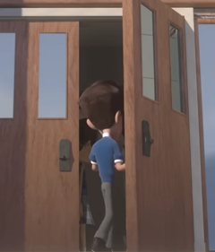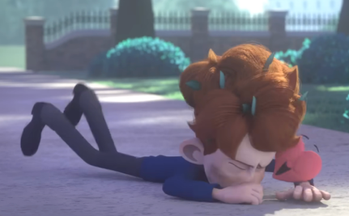
_______________ _______________ _________________ _________________
_________________ _________________ ____________________ _____________________
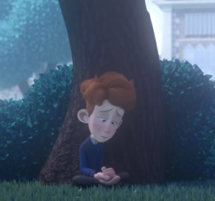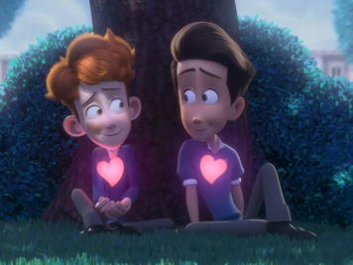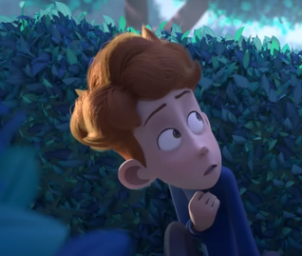
_______________ _______________ _________________ _________________
_________________ _________________ ____________________ _____________________
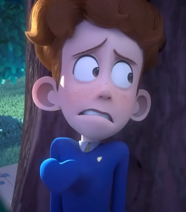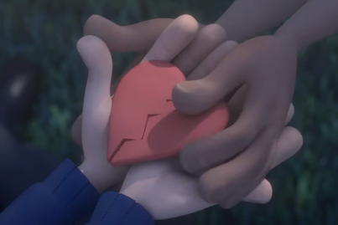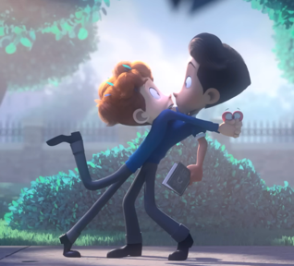
_______________ _______________ _________________ _________________
_________________ _________________ ____________________ _____________________

Now watch the short film and check your work.

Activity B: Which of the verbs above take ESSERE as their auxiliary verb when forming the passato prossimo?
Put them into categories and explain what type of category it belongs to that takes essere.

What other categories of verbs use ESSERE in the passato prossimo? Provide examples from each category.
___________________________________________________________________________________________________________________________________________________________________________________________________________________________________________________________________________________________________
Activity C: Now, imagine you are the protagonist of this film. Explain what happened the following day from your perspective (use as many of these ESSERE verbs as you can).
_______________________________________________________________________________________________________________________________________________________________________________________________________________________________________________________________________________________________________________________________________________________________________________________________________________________________________________________________________________________________________________________________________________________________________________________________________________________________________________________________________________________________________________________________________________________________________________________________________________________________________________________________________________________________________________________________________________________________________________________________________________________________________________________________________________________________________________________________________________________________________________________________________________________________________________________________________________________________________________________________________________________________________________________________________________________________________________________________________________________________________________

Activity D: If there is time, share your work with your peers. They are your friends and ask follow up questions about your new relationship/situationship.

